Sri Lanka Institute of Information

Technology



Lab Submission

<Lab sheet 06>

**<IT24103847>**

**<Jayarathna D.K.G.A>**

**Probability and Statistics | IT2120**

B.Sc. (Hons) in Information Technology

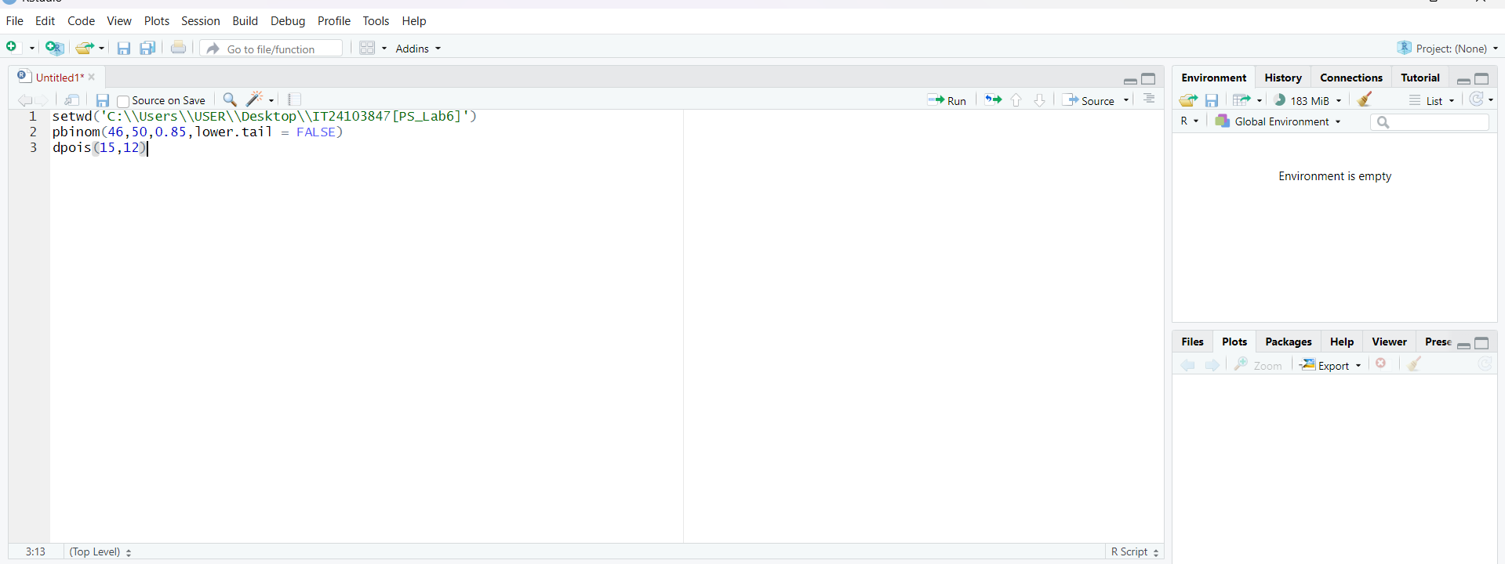

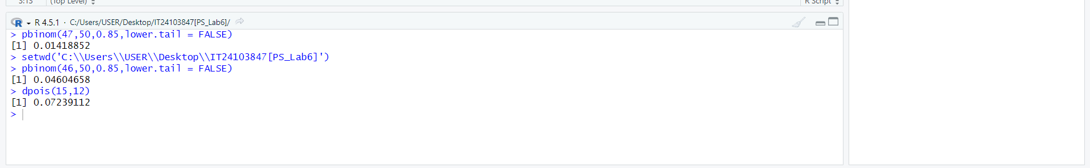

**Exercise**

1)

i What is the distribution of X?

Binomial distribution

P=0.85

n=50

ii. What is the probability that at least 47 students passed the test?

* 0.04604658

2)

i. What is the random variable (X) for the problem?

* Number of customer calls received per hour

ii. What is the distribution of X?

* Poisson distribution (λ=12)

iii. What is the probability that exactly 15 calls are received in an hour?

* 0.07239112